Choose the option that is cost-effective and can fulfill the requirements.

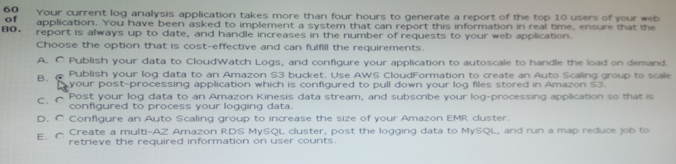

Ans:C

61.You have a web application that is currently running on a collection of micro instance type in a ……….

;;;;;;;;;;;;;;;;;;;;;;;;;;;;;;;;;;;;;;;;;;;;;;;;;;;;;;;;;;;;;;;;;;;;;;;;;;units and there is no throtting.

How do your service to improve the load times and ensure the principles of high availability?

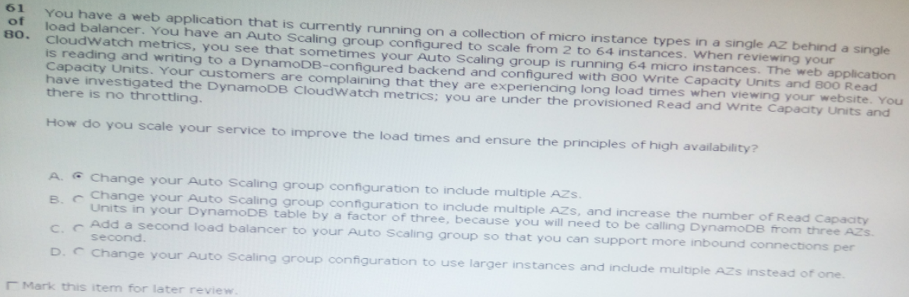

Ans:D

62.Your social media marketing application has a component written in ruby running an aws elastic beanstalk. This ………………………………………….apis in order to read the replies.

Which process should you use to record the social media replies in a durable data store that can be accessed at any time for analysis of historical data?

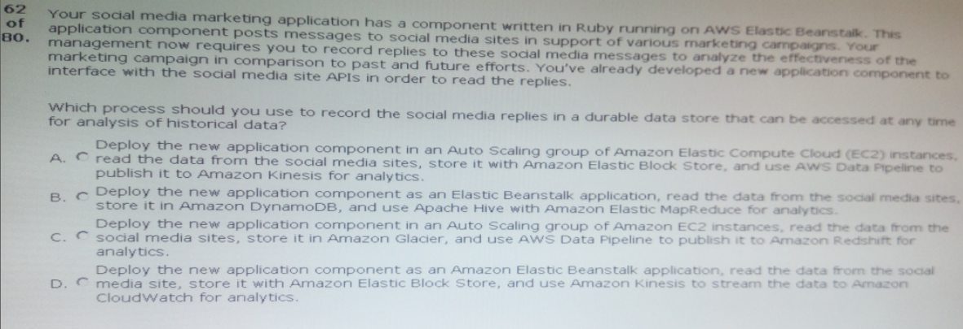

Ans:B

63.A web application is being actively developed by multiple development teams within your organization. You have created;;;;;;;;;;;;;;;;;;;;;;;;;;;;;;;;;;;;;;;;;;;;;;;;;;;;;;;;;;;;;;;;;;;broken environment.

Select a suitable way to implement such a feature into the existing self-service portal:

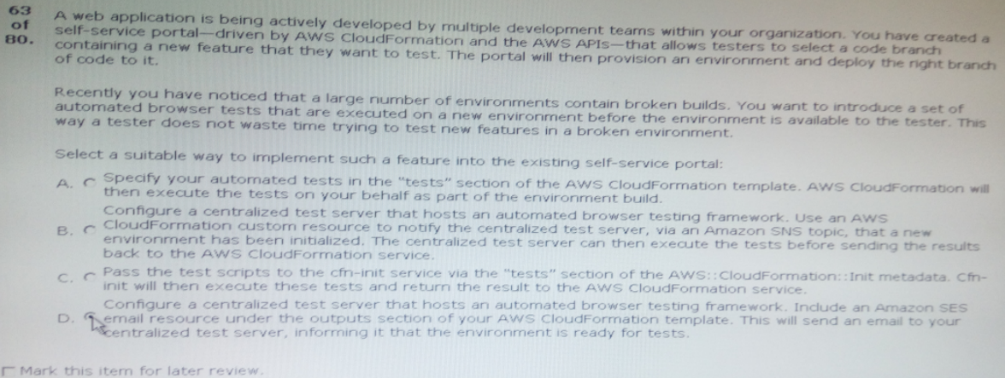

Ans:B

64.You have written a server-side node. Js application and a web application with an HTML/javascript front end that ;;;;;;;;;;;;;;;;;;;;;;;;;;;;;;;;;;;;;;;;;;;;;;cost of running this application low.

Which deployment strategy is both technically valid and the most cost-effective?

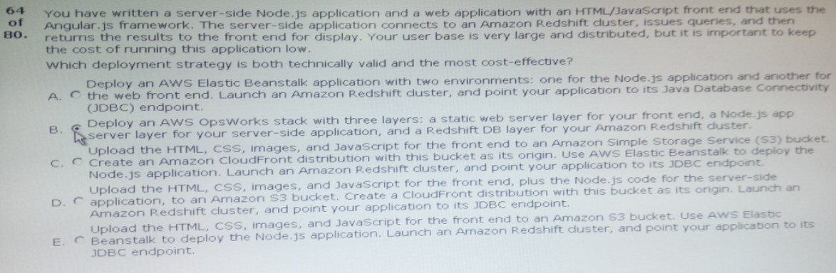

Ans:A

65.You are building an aws cloudformation template for a multi-tier web application. The user data of your linux …………………….long to run.

Which techniques could …………………..running before attaching them to the load balancer?

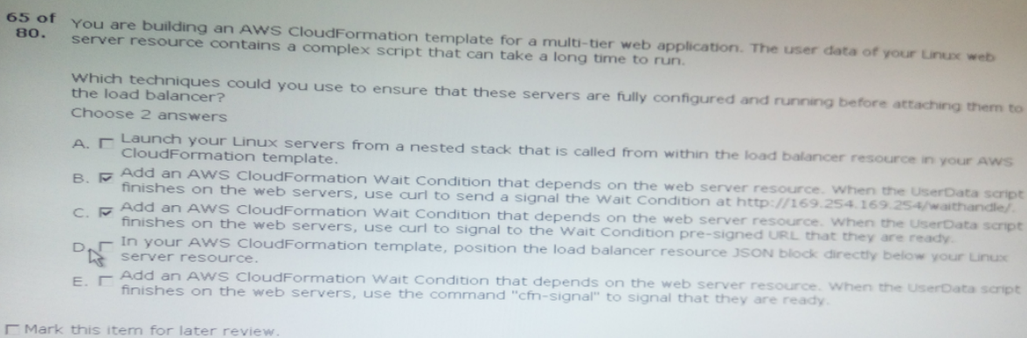

Ans:A,E

66.customers have recently been complaining that your web application has randomly stopped …..

………built with AWS cloudformation.

Which techniques should you use to help detect these problems faster, as well as help eliminate the server’s unresponsiveness?

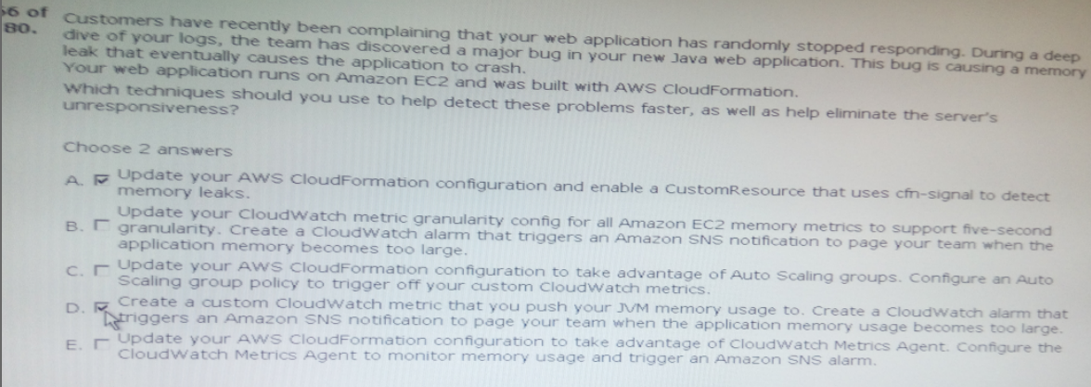

Ans:C,D

67.You’re responsible for a popular file sharing application that uses elastic load balancing to distribute traffic to ………………………………..in the last five minutes.

What steps should you take to ensure that your application tier scales based on this new policy?

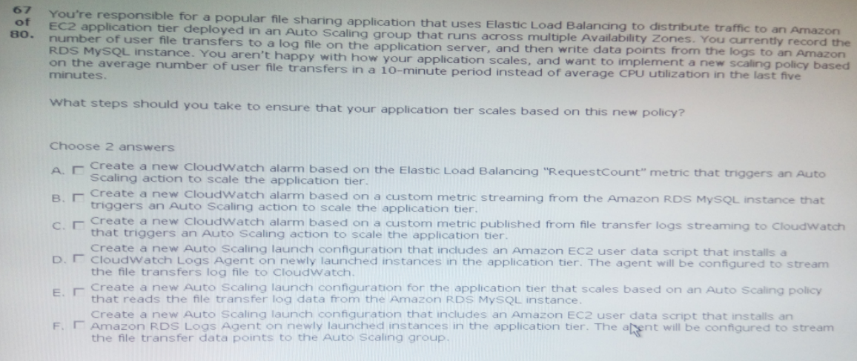

Ans:C,D

68.Your devops team is responsible for a multi-tier, window-based web application consisting of web servers, amazon RDS database ………………………….for this web application.

What method should you use?

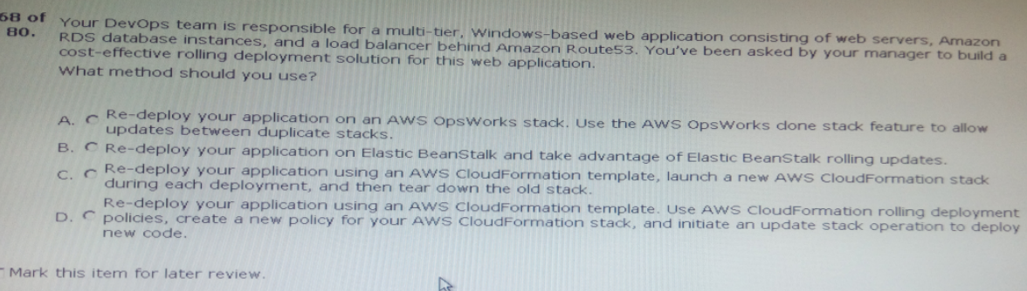

Ans:D

69.You recently encountered a major bug in your windows-based web application during a deployment cycle. During……………………………….your load balancing needs.

Which technique should you use to solve this problem?

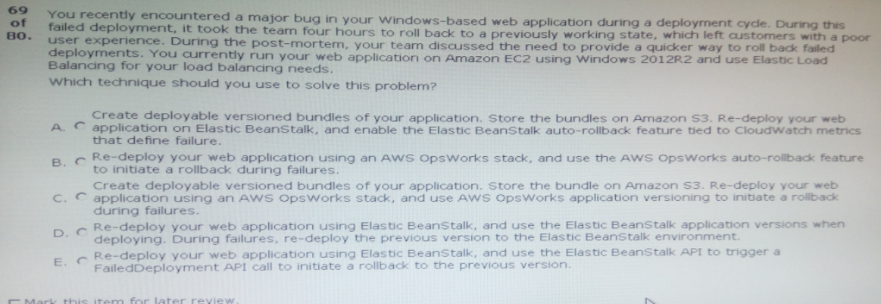

Ans:B

70.You have a high-traffic application running behind a load balancer with ……………………….instances are causing increased latency so that they can be replaced?

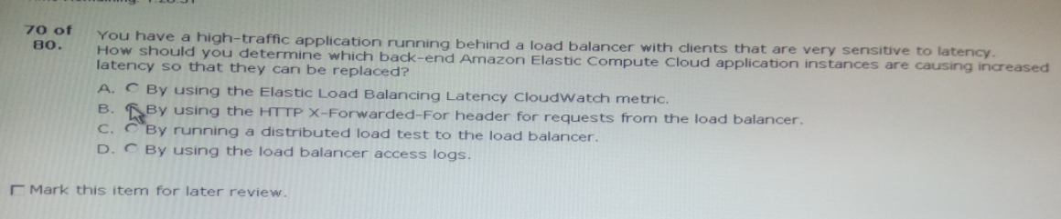

Ans:A

Your company operates an application consisting of an aws cloudformation stack that contains a load …………………………………once with a configuration management database (CMDB).

What cost-effective solution should you choose to perform this registration?

Ans:B

72.You manage a three-tier web application consisting of an autoscaled web proxy tier, an autoscaled application ……………………..your web and application instances have been terminated. what may have caused this?

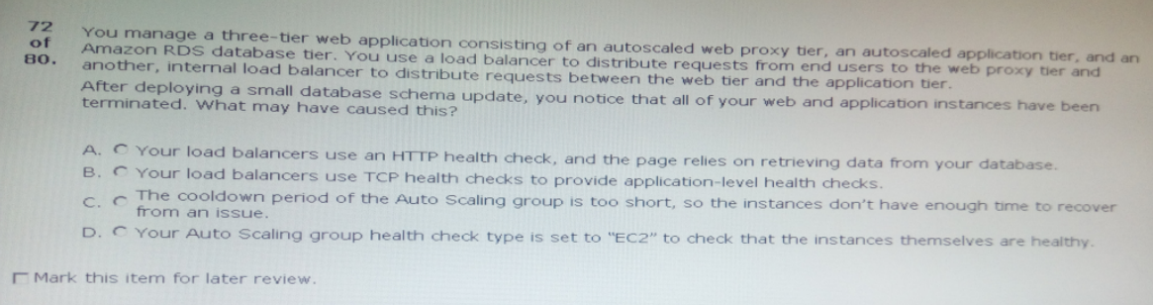

Ans:A

73.You have an ASP.NET web application running in amazon Elastic beanstalk. Your ……………………..first boot and before the application launches. Which options are possible?

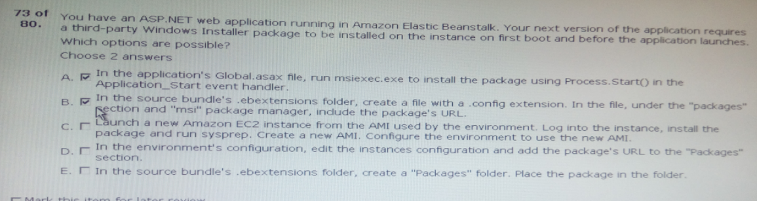

Ans:B,C

74.You are using elastic beanstalk to manage your e-commerce store. The store is based on an open ;;;;;;

;;;;;;;;;;;;;;;;;;;;;;;;;;;;;;;;;;;;;;SQL script is only executed once per deployment regardless of how many amazon EC2 instances are running at the time?

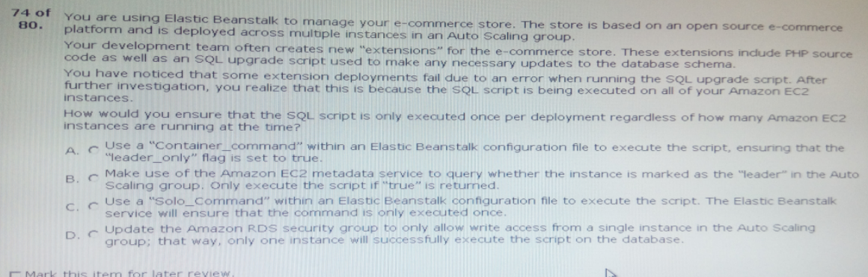

Ans:B

75.You are administering a continuous integration application that polls version control for changes and then launches new ;;;;;;;;;;;;;;;;;;;;;;;;;;;;;;overall cost while being able to run as many tests in parallel as possible?

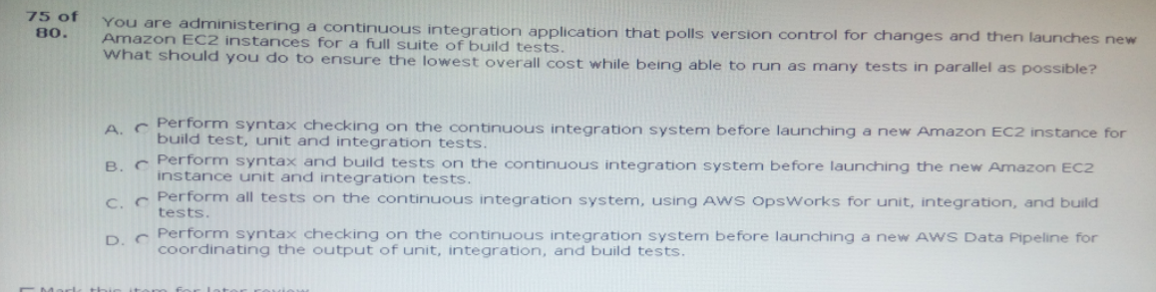

Ans:B

76.You are doing a load testing exercise on your application hosted on aws. While test…;;;;;;;;;;;;;;;;;;;

;;;;;;;;;;;;;;;;;;;;;;read-heavy.

What are methods to scale your data tier to meet the application’s needs?

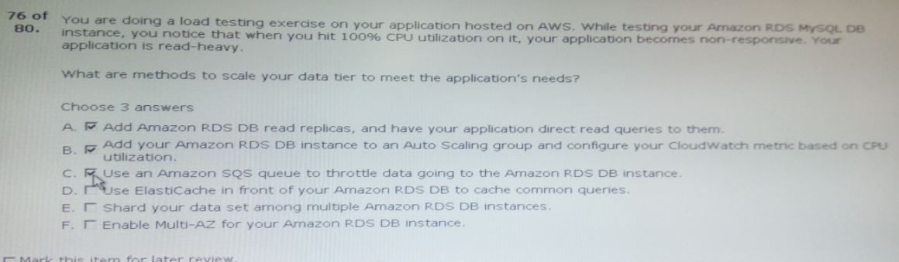

Ans:A,D,F

77.Your mobile application includes a photo-sharing service that is expecting tens of thousands of ;;;;;;;

;;;;;;;;;;;;;;;;storage of these images.

Which two of the following approaches should you use?

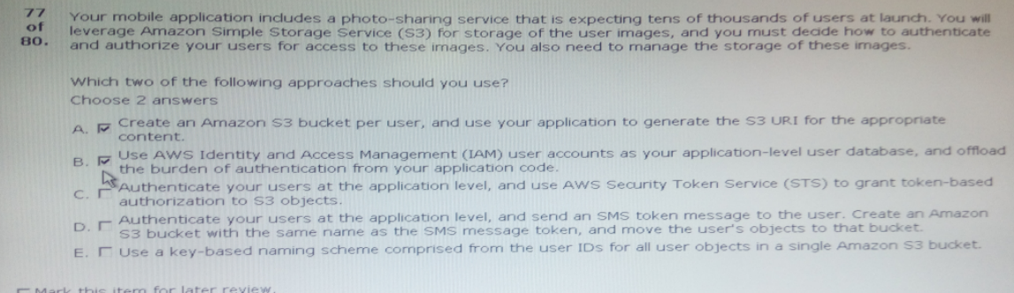

Ans:C,E

78.You have an auto scaling group of instances that processes messages from an amazon simple ;;;;;;;;;

;;;;;;;;;;;;;;;;;;;;;;;;;;;are being terminated while they processing.

What cost-effective solution can you use to reduce the number of incomplete process attempts?

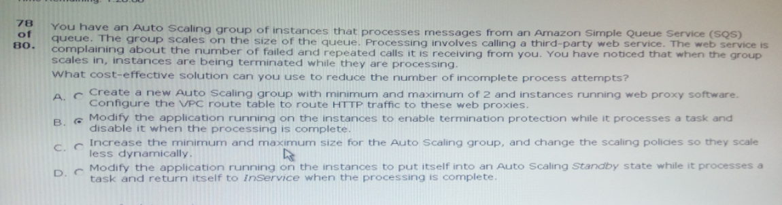

Ans:C

79.The operations team and the development team want a single place to view both operating system and application logs.

How should you implement this using AWS services?

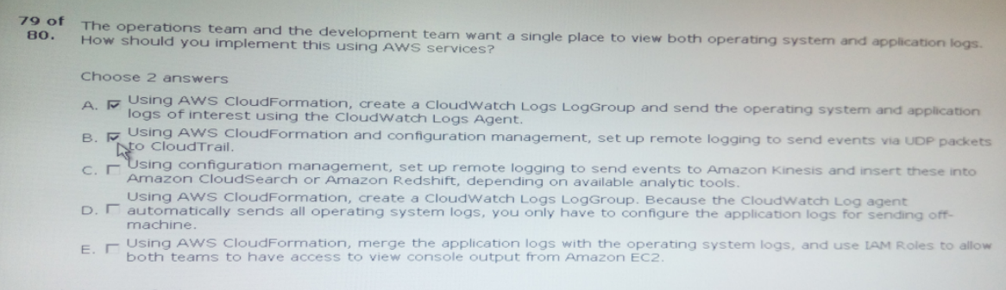

Ans:A,C

80.The project you are working on currently uses a single aws cloudformation template to deploy its aws ;;;;;;;;;;;;;;;;;;;;;;;;;;;;;;;;;;;;;;;;;;;;;;;;;;;;can review the architecture before it goes to production.

How should you do this in a way that accommodates each department, using their existing workflows?

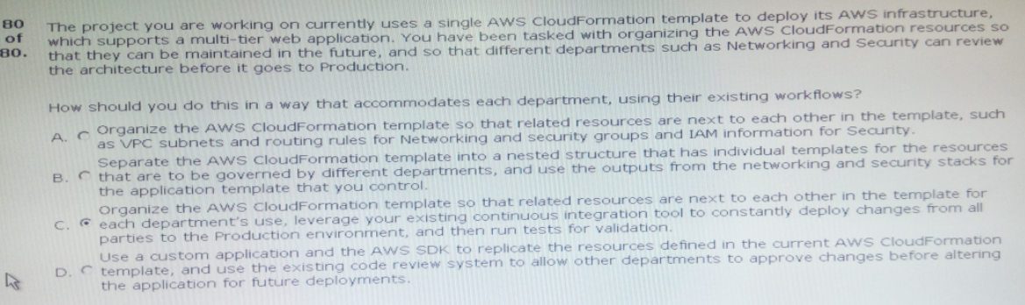

Ans:B